Christchurch City Council Receives Prestigious Award

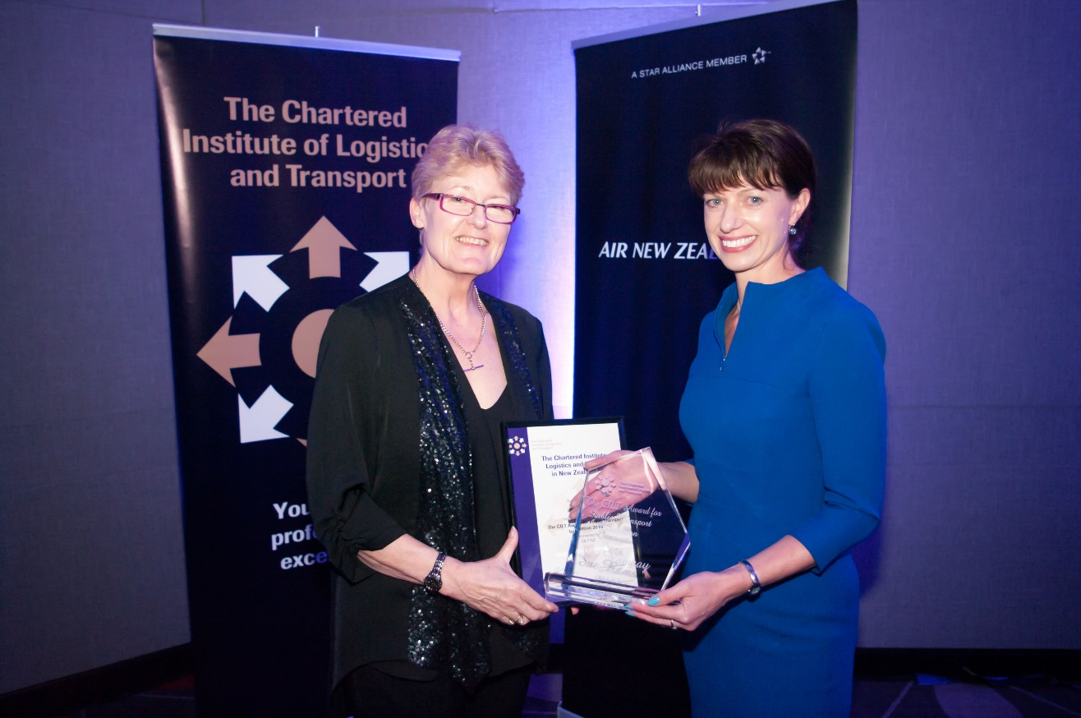
Raewyn Bleakley, Regional Director NZTA Wellington, presents the CILT Award for Public Transport Innovation to Sue Ramsay, Christchurch City Council

On 12 October, Sue Ramsay, Christchurch City Council, received the 2016 Public Transport Innovation Award from the Chartered Institute of Logistics and Transport (CILT) for the use of CPTED (Crime Prevention through Environmental Design) in the new Christchurch Bus Interchange and surrounds. The Bus Interchange is Christchurch’s main public transport hub and is located in the central city.

This award recognises notable innovation in public transport in New Zealand and has done so by acknowledging the innovative and extensive application of non-traditional crime reduction features in the design of the Bus Interchange, and the resulting increase in public safety.

CPTED was applied extensively throughout the design phases of the Bus Interchange and 80% of the forty four detailed recommendations were integrated into the design. This was achieved without adding additional costs to design or construction.

Police calls for service data show a 70% reduction (adjusted for passenger boarding loads) in the first year of operation of the Interchange, compared to the last full year of operation of the previous Bus Xchange, which was a crime hotspot.

Safety in the Interchange has been improved through a suite of complementary and subtle safety features including seating options, public toilet placement and design, activation of the north façade, clear sightlines, and wide footpaths outside the building.

